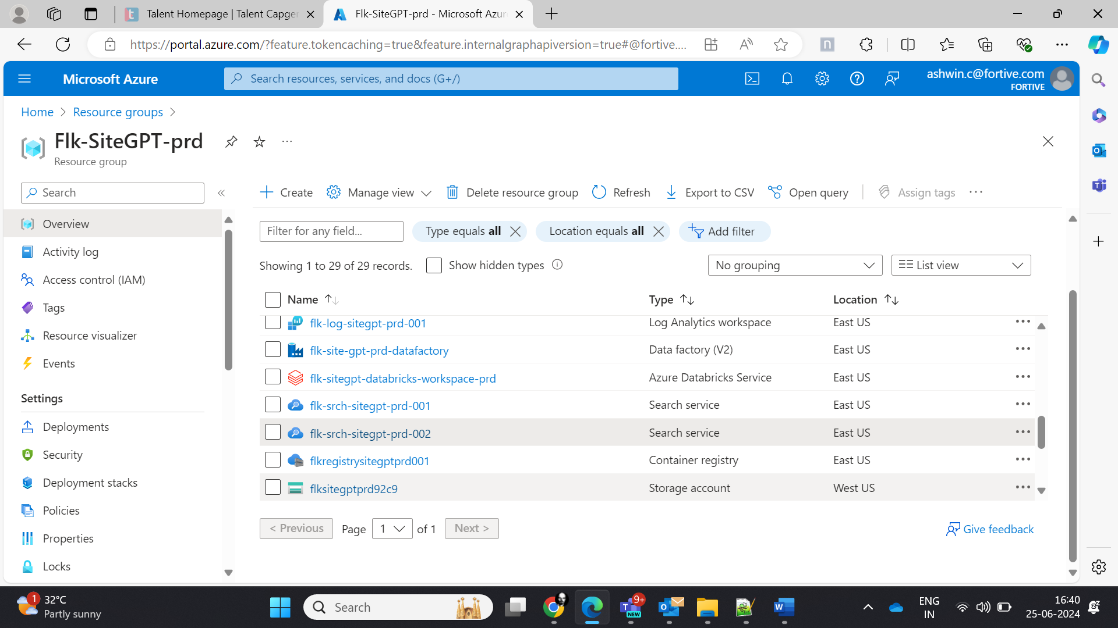

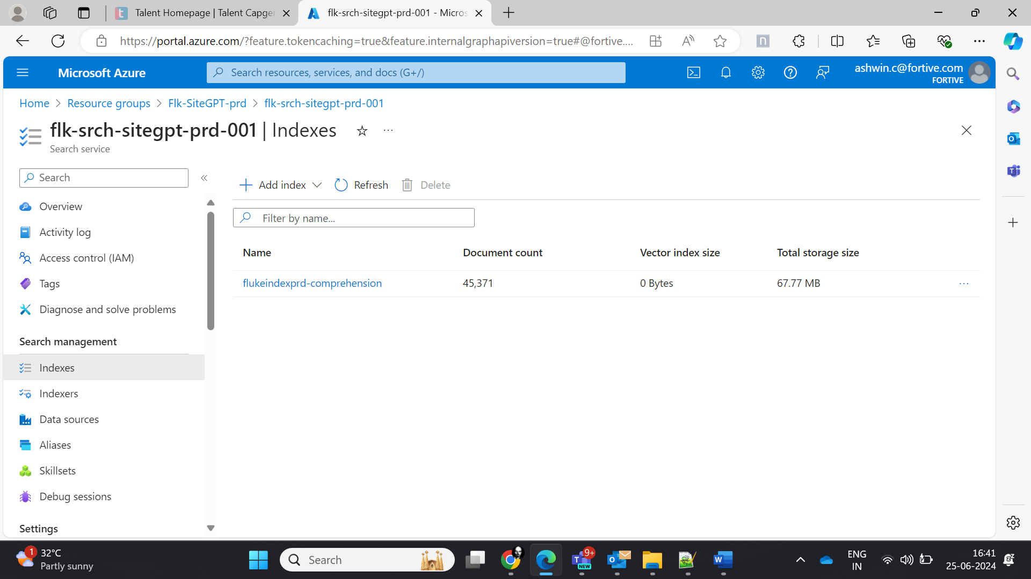

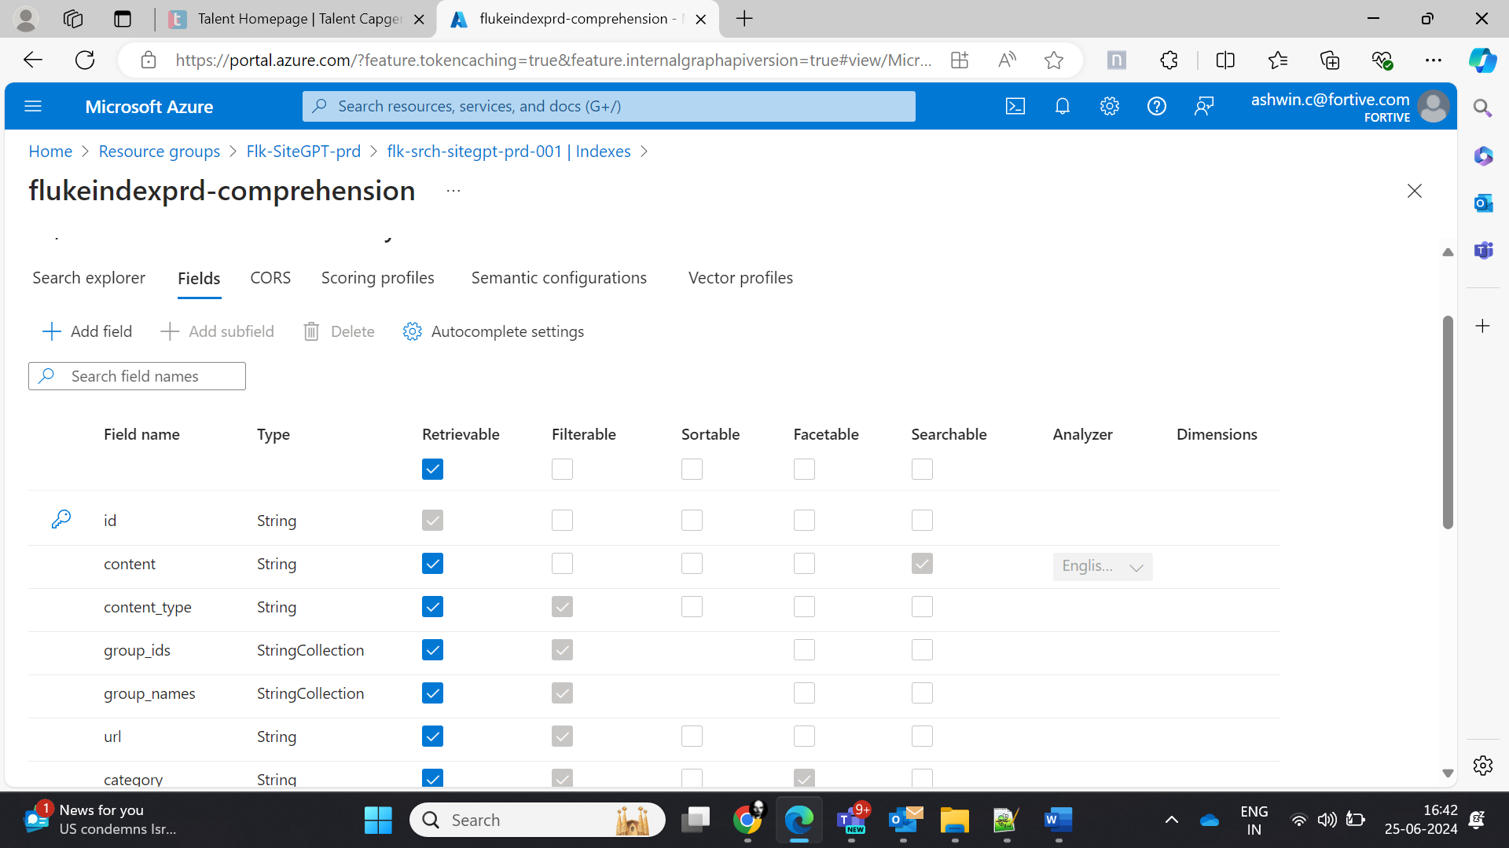

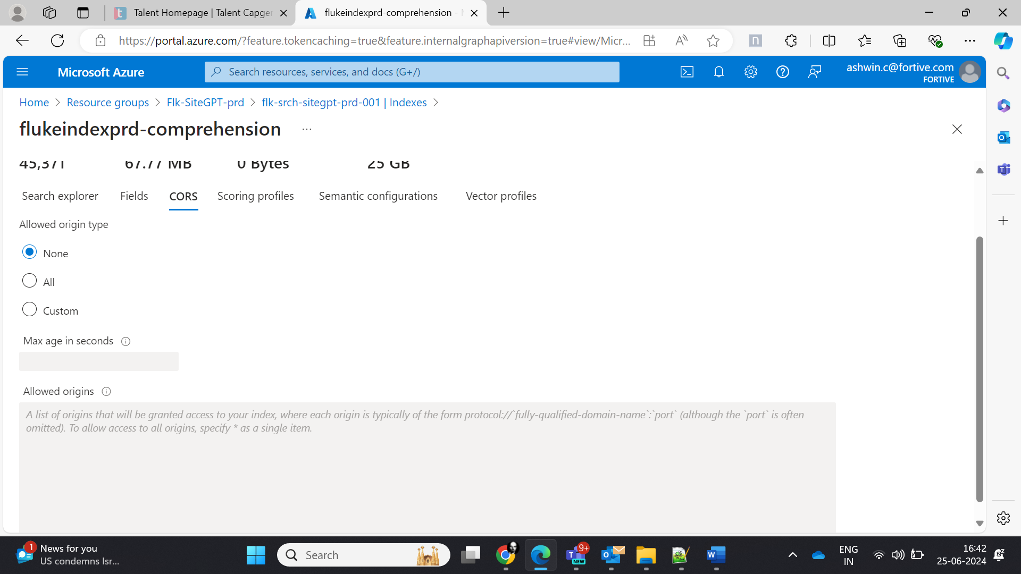

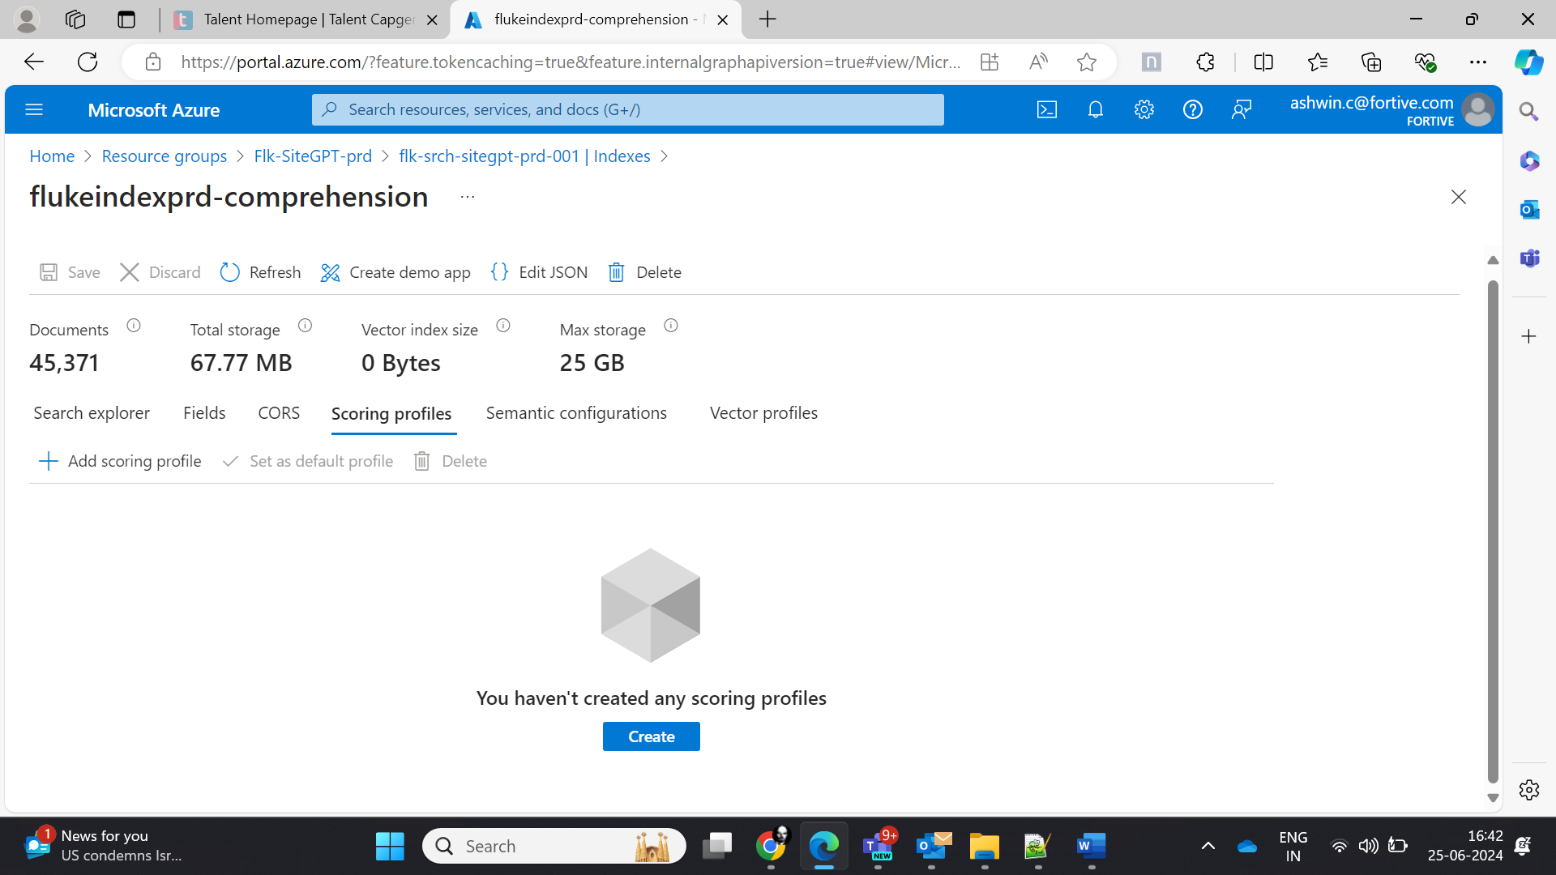

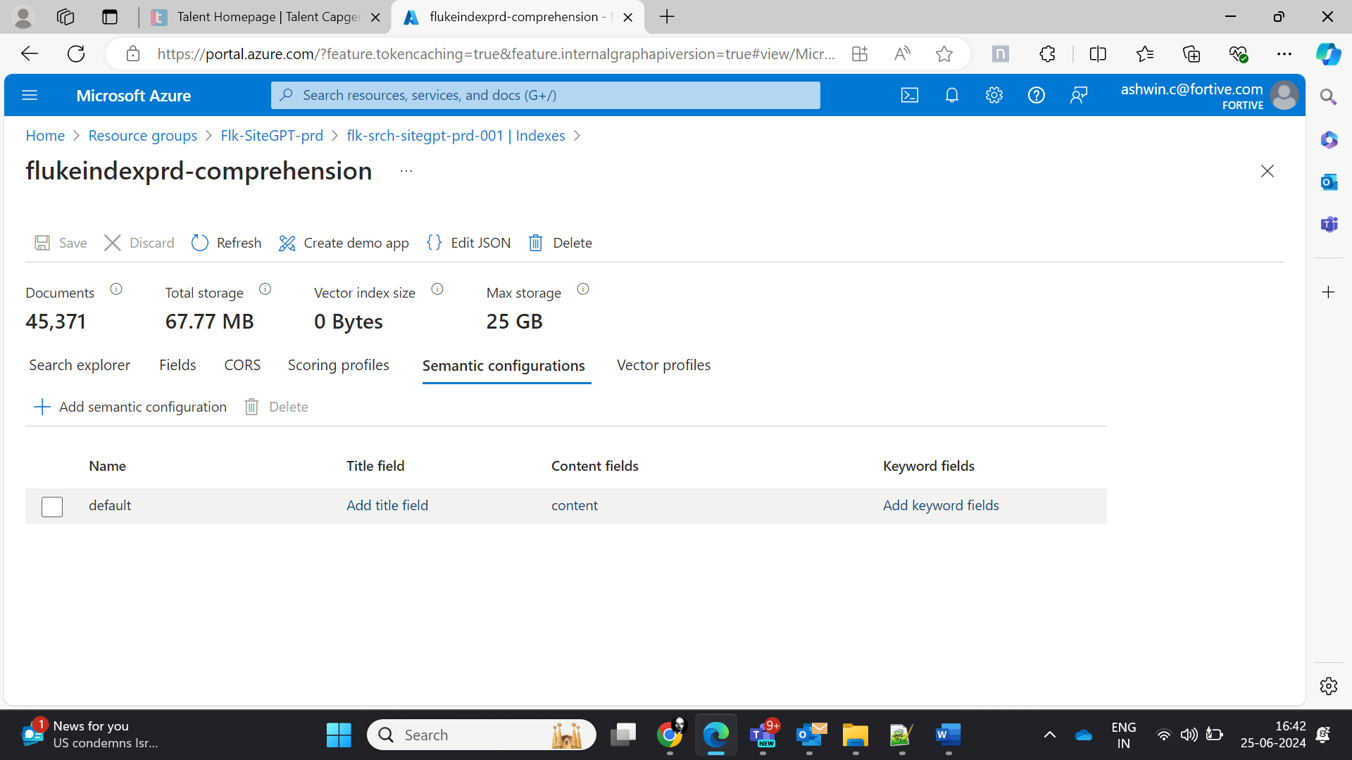

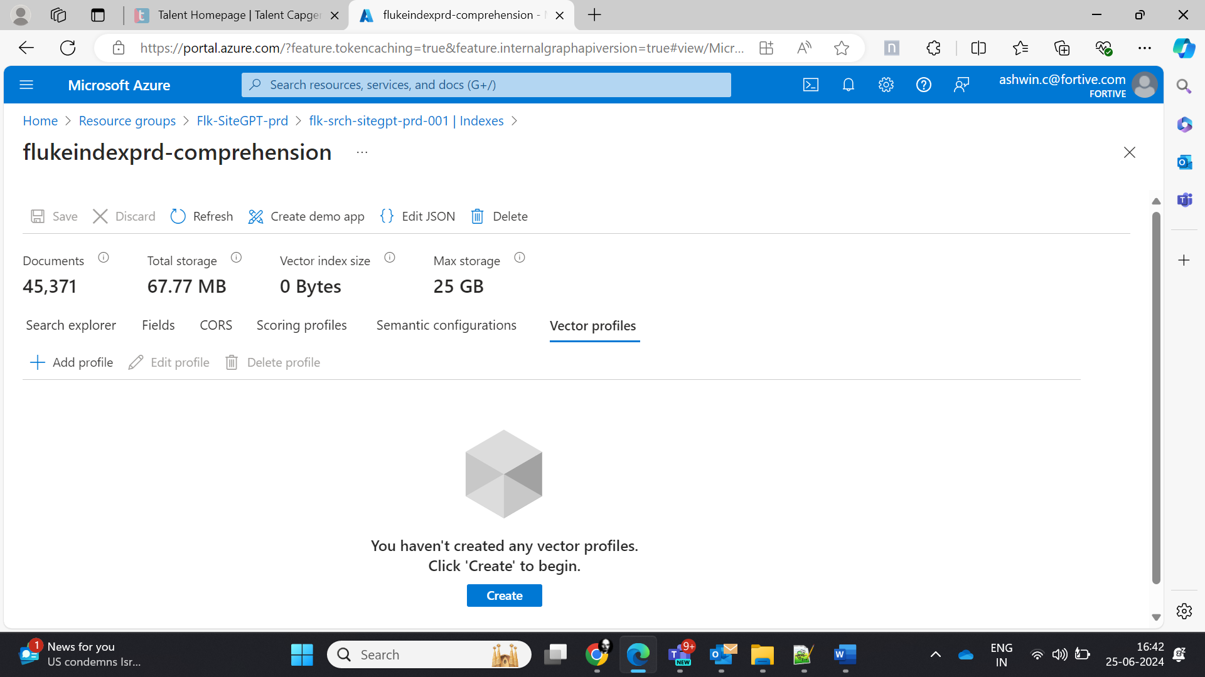

Second cognitive search for multiple language:

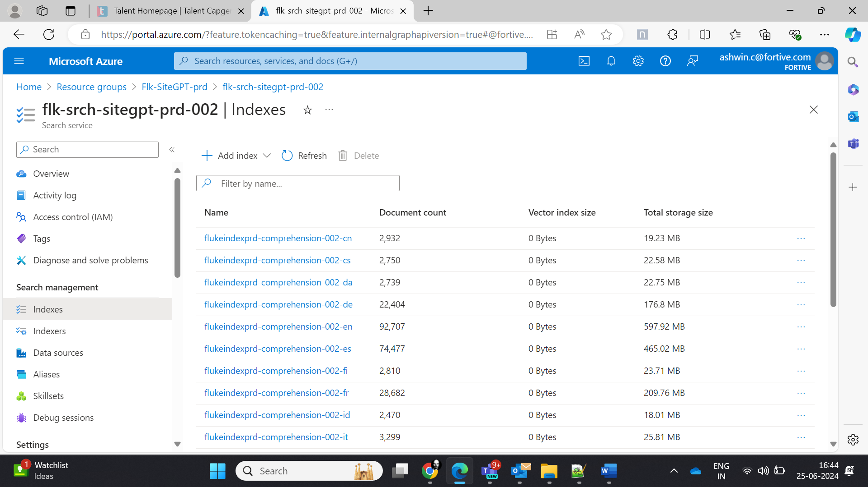

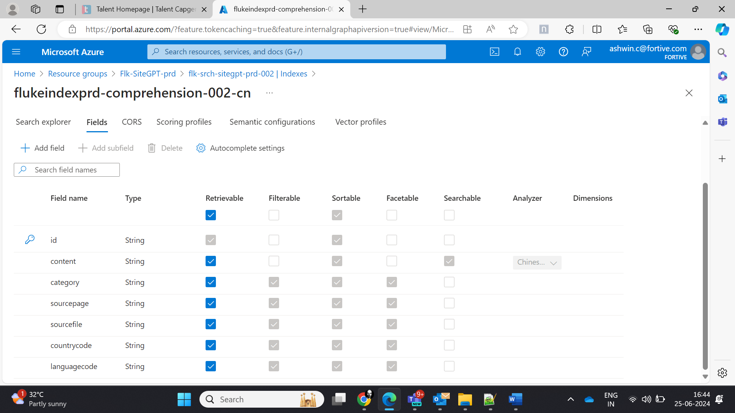

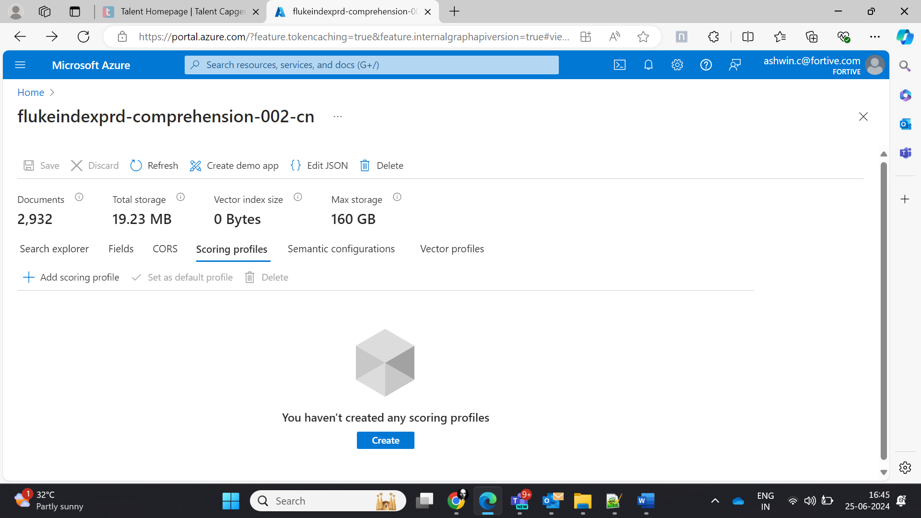

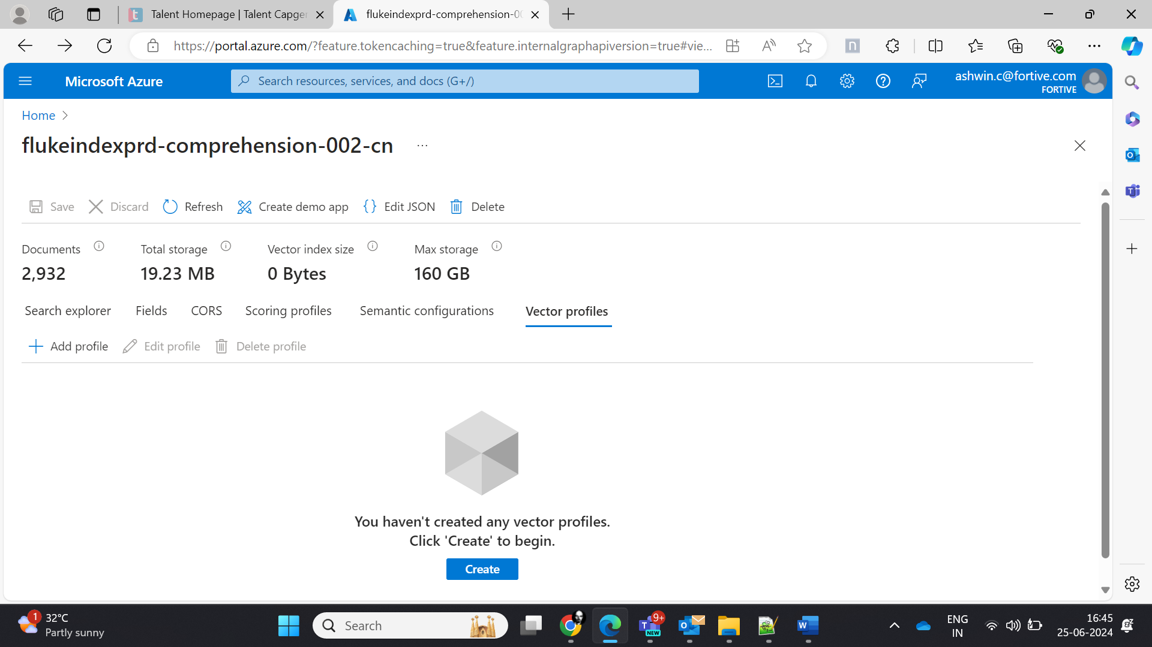

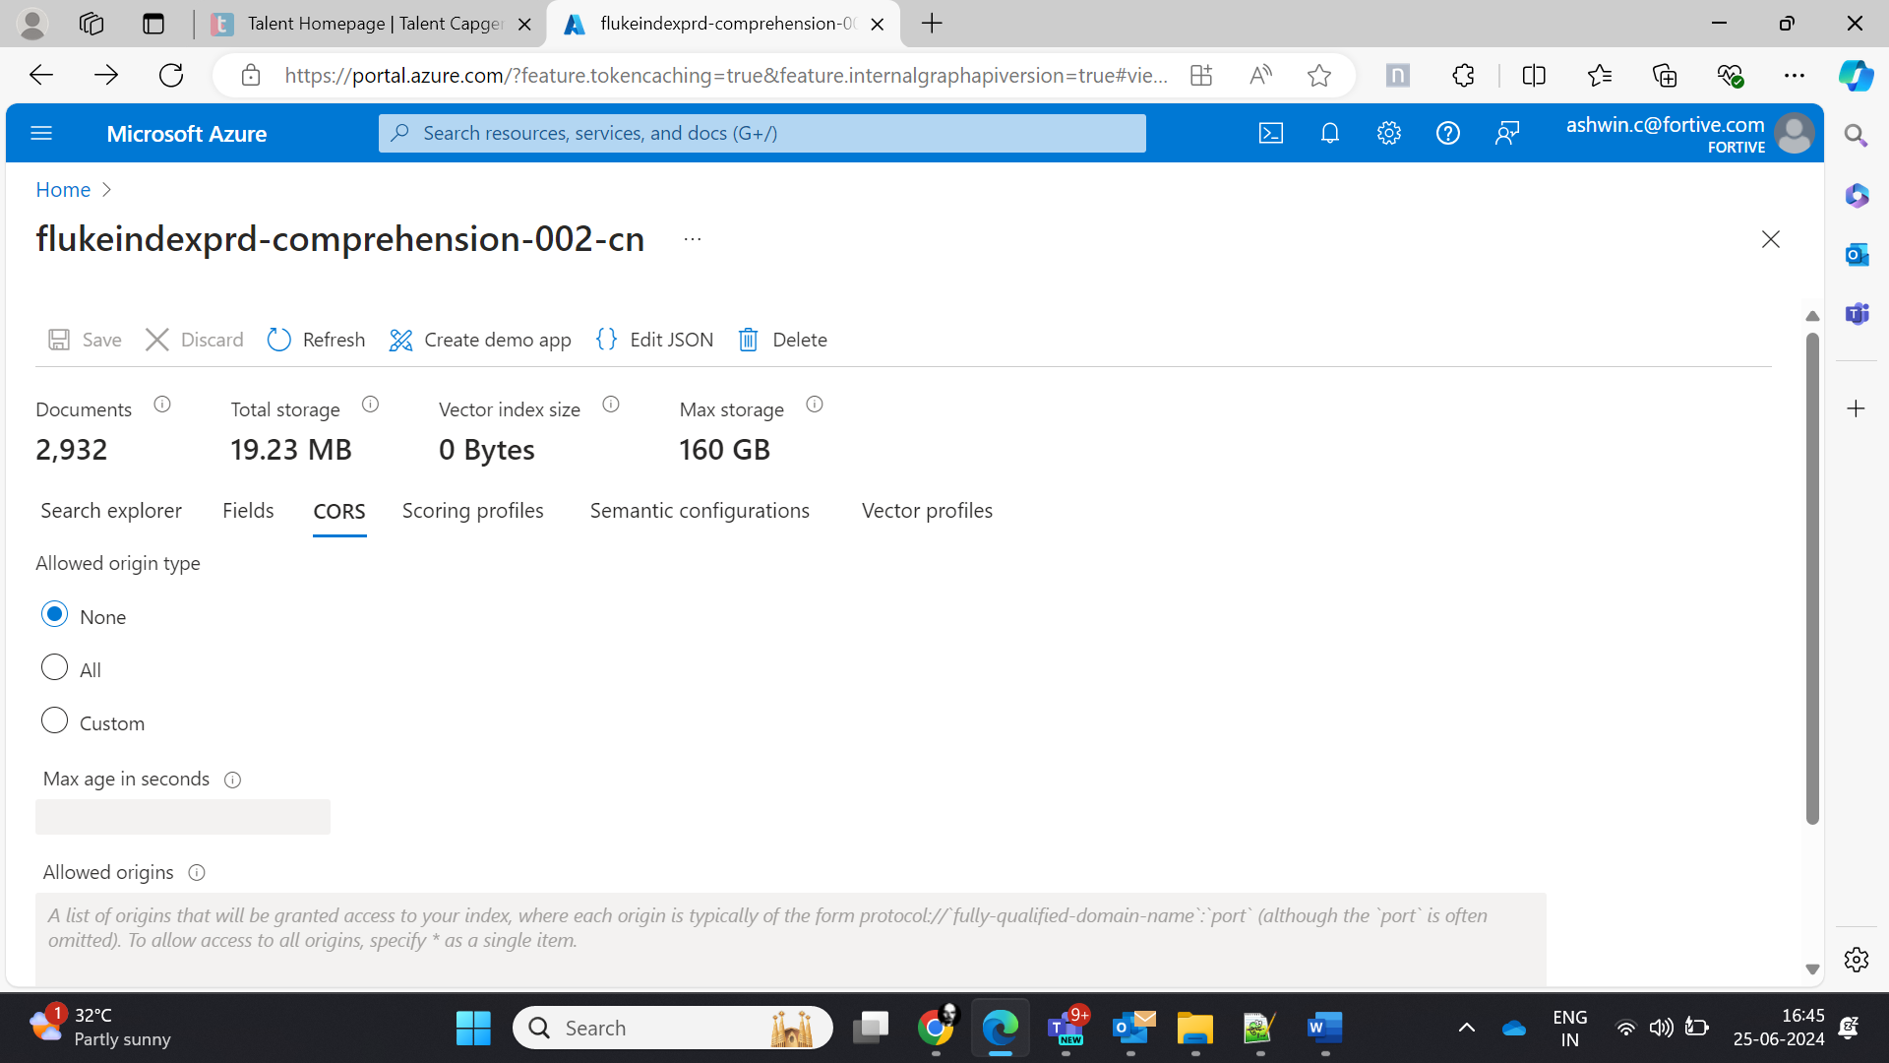

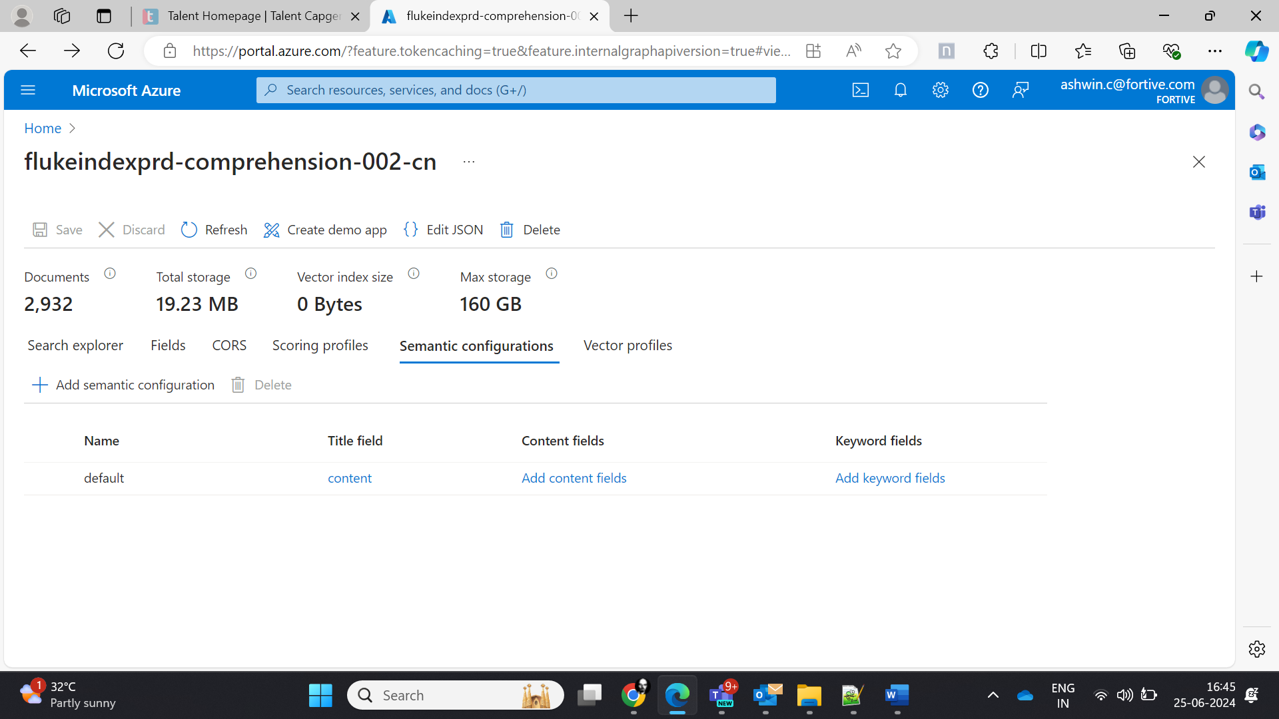

For Czech language:

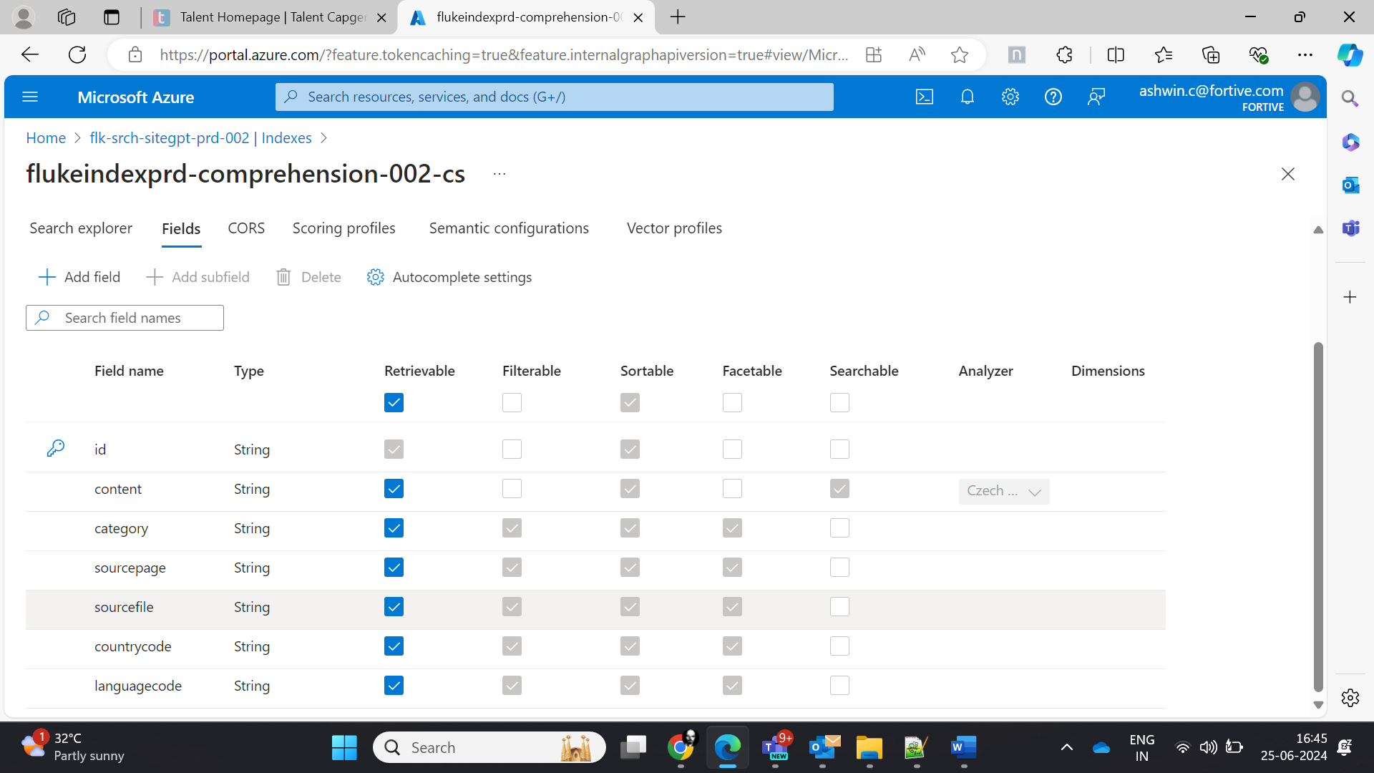

Indexer:

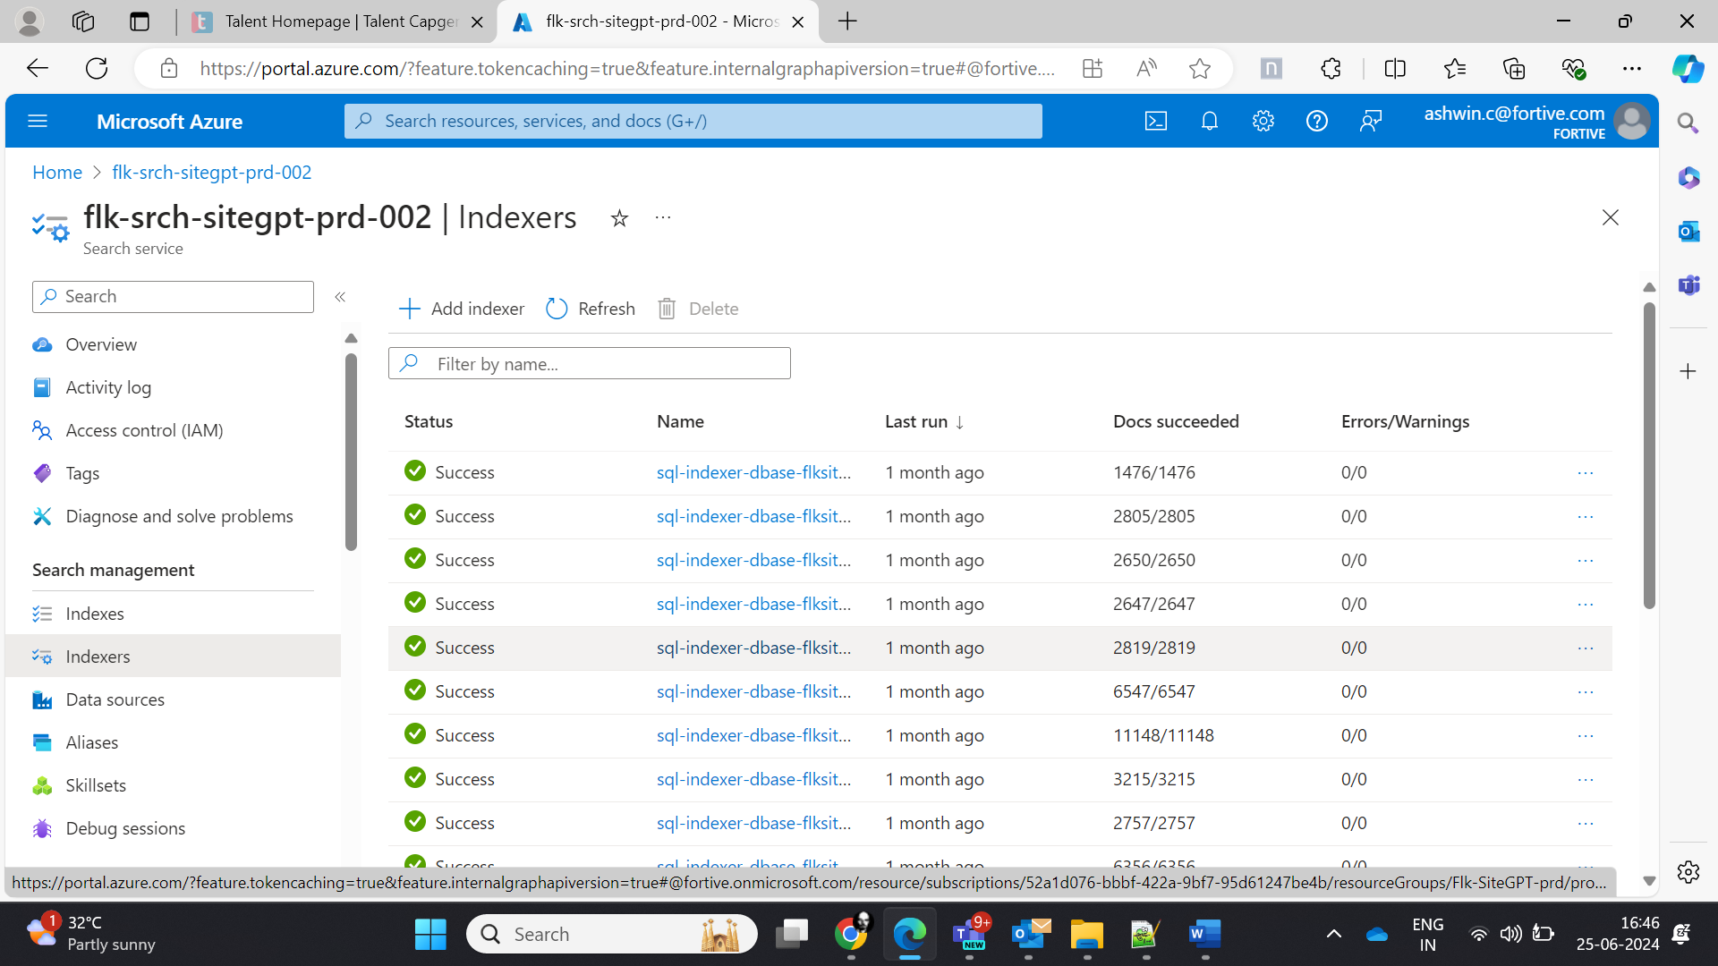

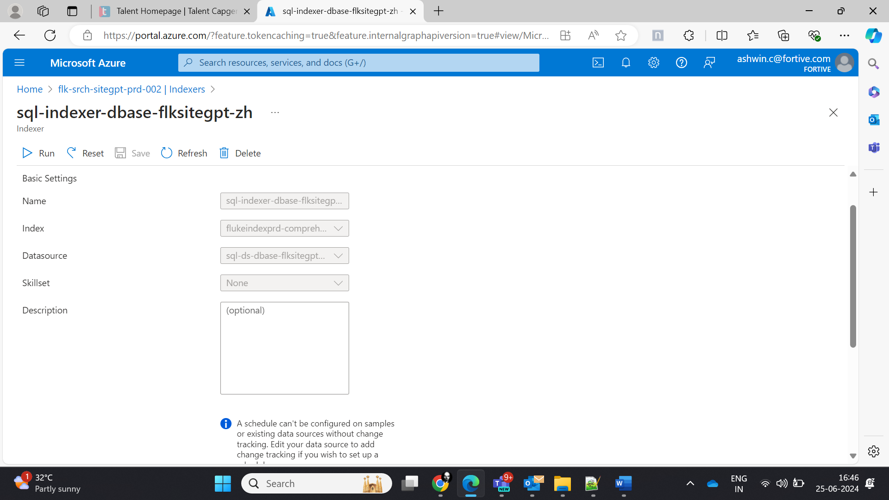

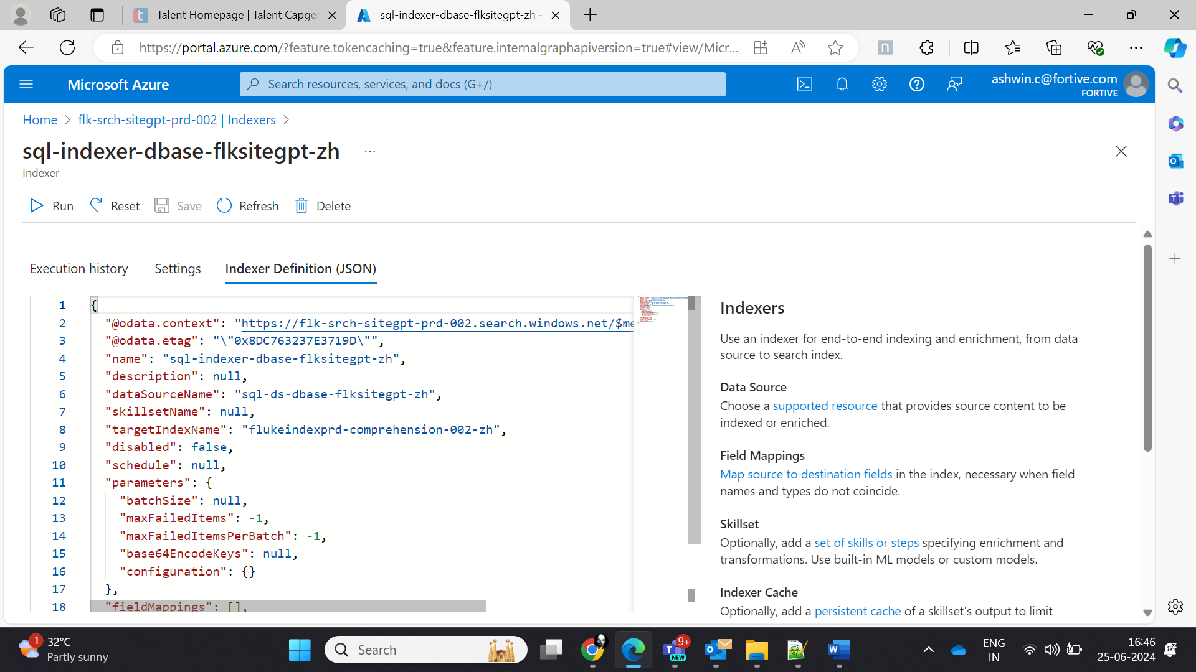

JSON definition:

{

  "@odata.context": "https://flk-srch-sitegpt-prd-002.search.windows.net/$metadata#indexers/$entity",

  "@odata.etag": "\"0x8DC763237E3719D\"",

  "name": "sql-indexer-dbase-flksitegpt-zh",

  "description": null,

  "dataSourceName": "sql-ds-dbase-flksitegpt-zh",

  "skillsetName": null,

  "targetIndexName": "flukeindexprd-comprehension-002-zh",

  "disabled": false,

  "schedule": null,

  "parameters": {

    "batchSize": null,

    "maxFailedItems": -1,

    "maxFailedItemsPerBatch": -1,

    "base64EncodeKeys": null,

    "configuration": {}

  },

  "fieldMappings": [],

  "outputFieldMappings": [],

  "cache": null,

  "encryptionKey": null

}

Datasource:

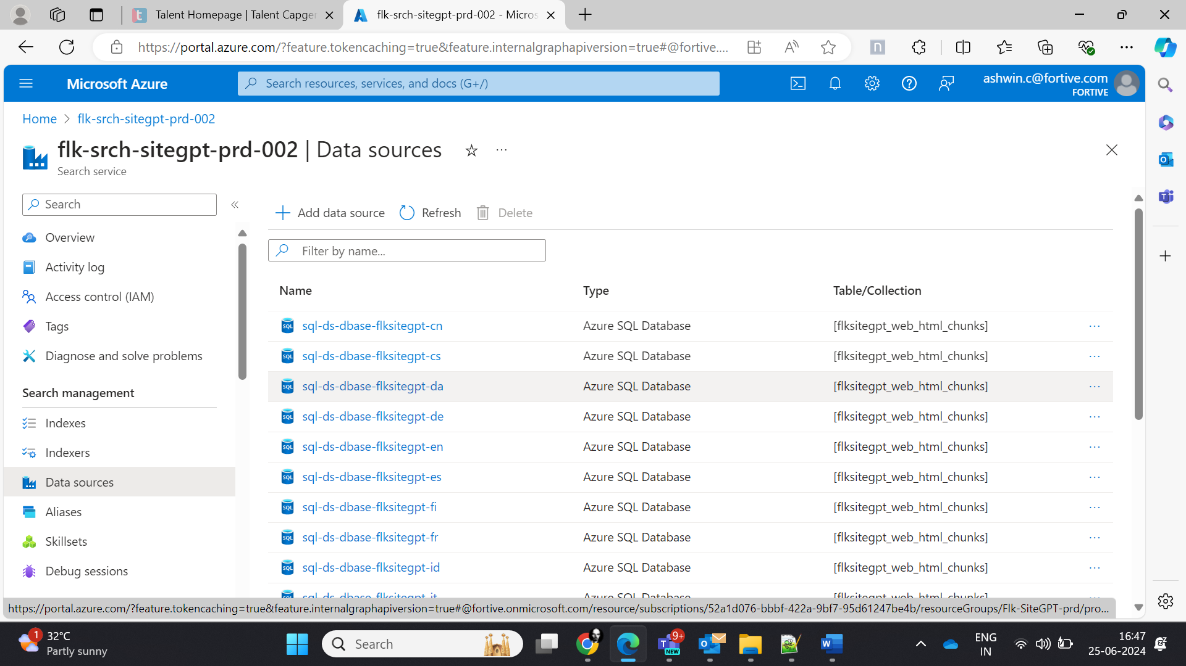

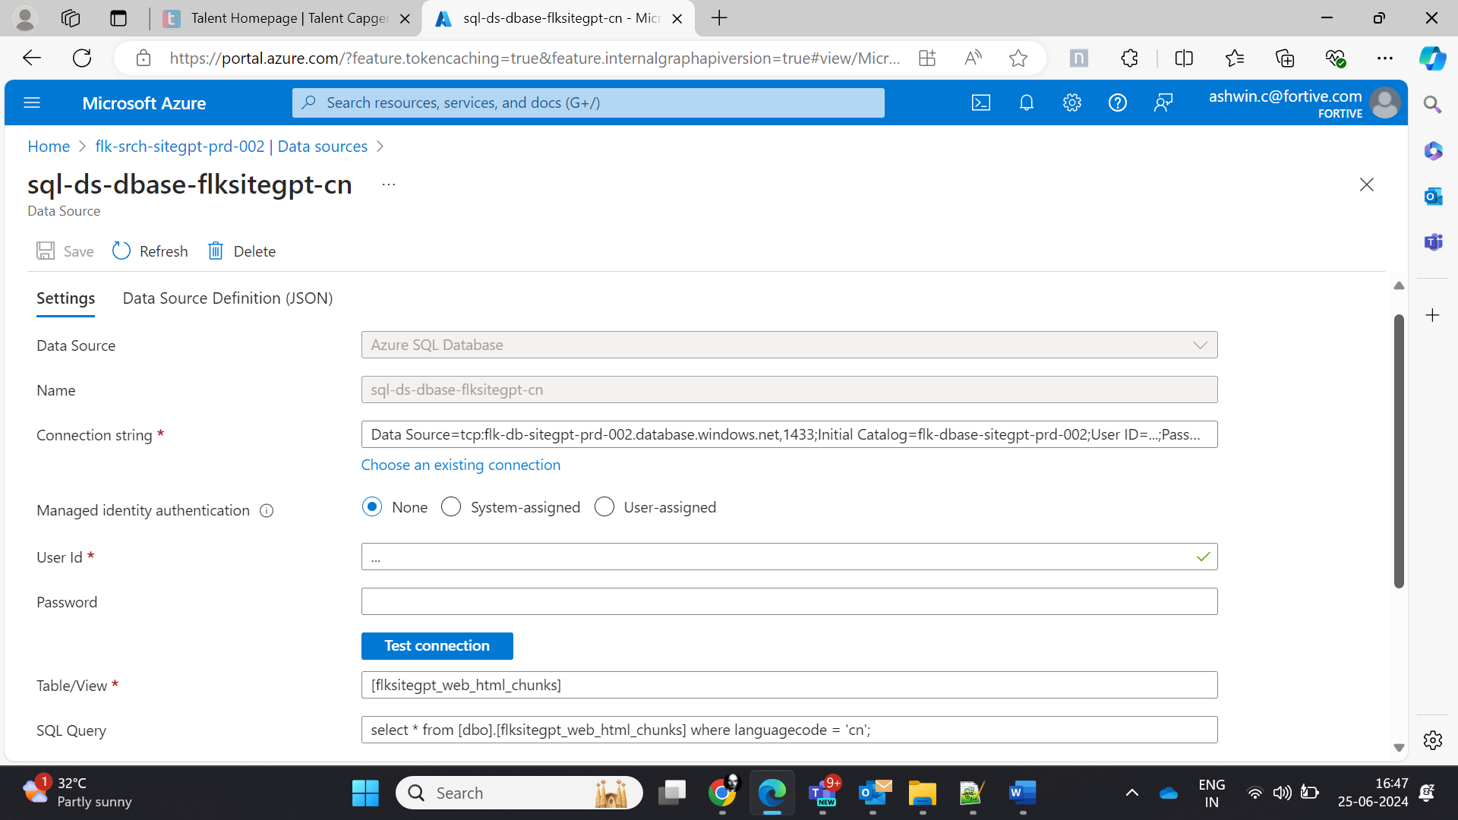

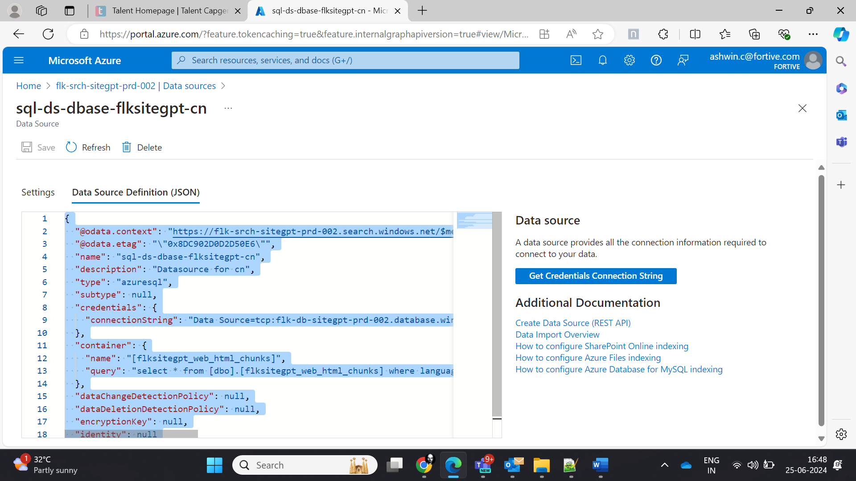

{

  "@odata.context": "https://flk-srch-sitegpt-prd-002.search.windows.net/$metadata#datasources/$entity",

  "@odata.etag": "\"0x8DC902D0D2D50E6\"",

  "name": "sql-ds-dbase-flksitegpt-cn",

  "description": "Datasource for cn",

  "type": "azuresql",

  "subtype": null,

  "credentials": {

    "connectionString": "Data Source=tcp:flk-db-sitegpt-prd-002.database.windows.net,1433;Initial Catalog=flk-dbase-sitegpt-prd-002;User ID=...;Password=...;Connect Timeout=30;Encrypt=True;Trust Server Certificate=False"

  },

  "container": {

    "name": "[flksitegpt_web_html_chunks]",

    "query": "select * from [dbo].[flksitegpt_web_html_chunks] where languagecode = 'cn';"

  },

  "dataChangeDetectionPolicy": null,

  "dataDeletionDetectionPolicy": null,

  "encryptionKey": null,

  "identity": null

}